Exercise No 8: TraceRoute, ping, ifconfig, ipconfig, netstat

Aim: Using TraceRoute, ping, ifconfig(LINUX), ipconfig(WINDOWS), and netstat Command.

Procedure:

Step 1: open windows command prompt and Type tracert command and type tracert www.saveetha.com -> “Enter”

Step 2: Type ping command and type IP Address press “Enter”

Step 3: Type ifconfig command

Step 4: Type netstat command

OUTPUT:

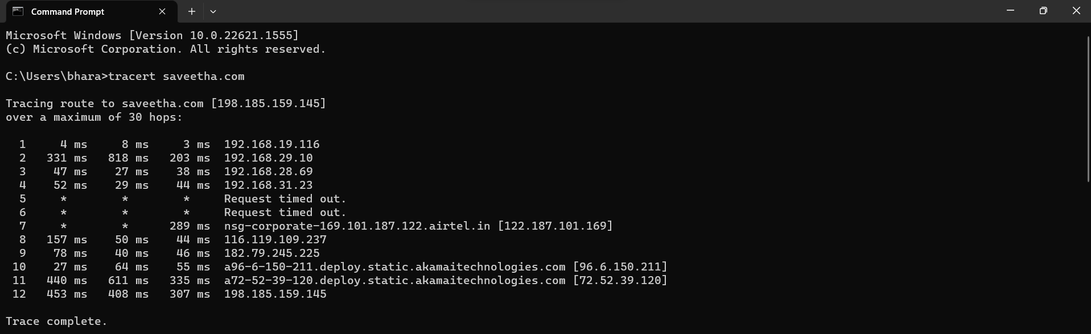

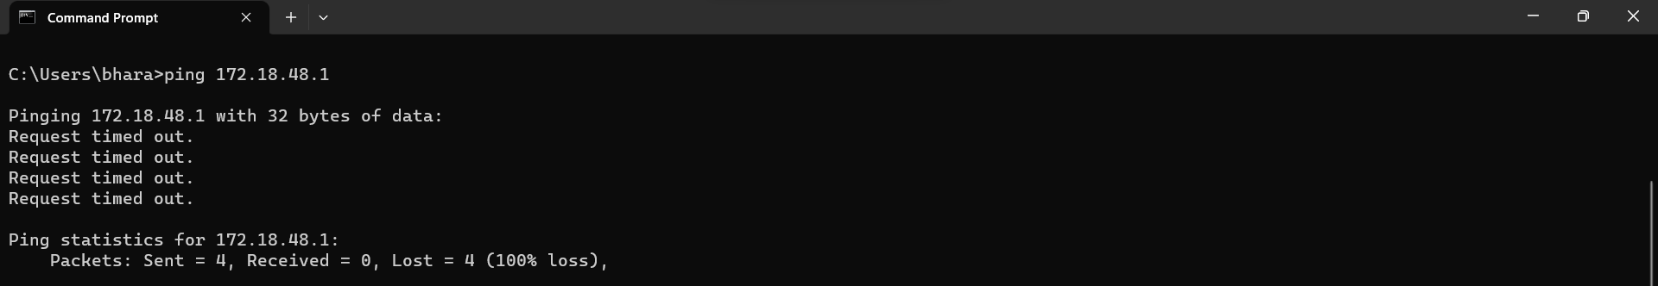

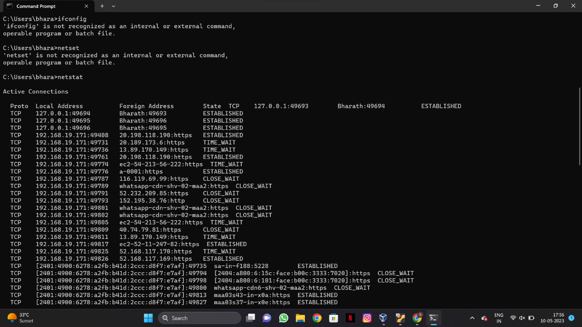

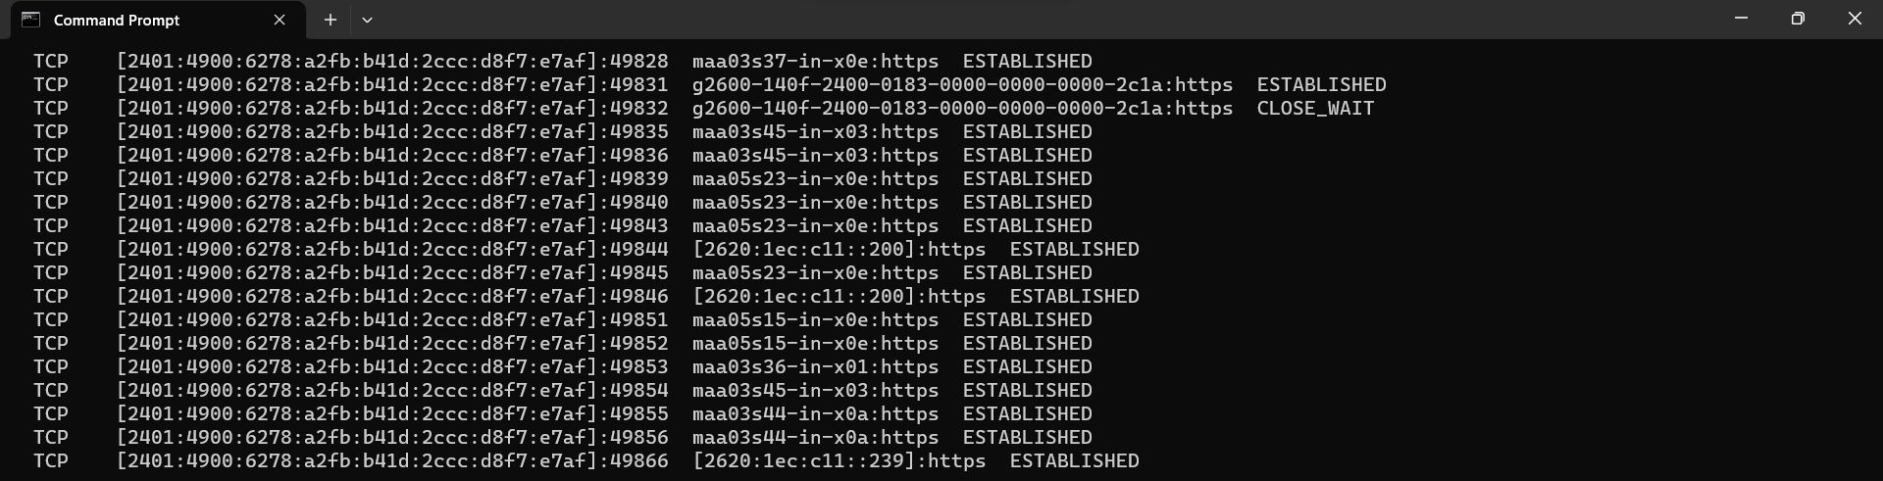

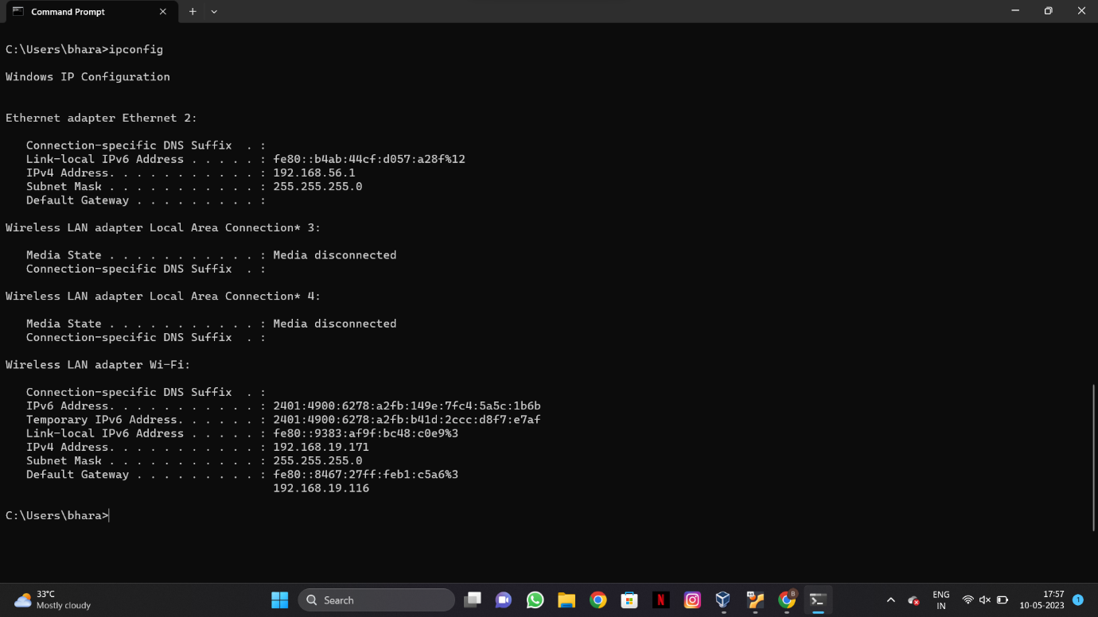

RESULT :Hence the above commands are executed successfully.